ECPI University Rafat Khandaker

CIS_126 07/31/18

Unit 1 Graded Assignment 3

In this assignment, I have programmed a graded assignment workflow that will return a pass or fail logic every-time a grade is entered. I have prompted the user to input a valid grade between 0 & 100. Any grade outside this boundary will execute a conditional statement that will show an "invalid prompt message" & re-run the task. When a valid grade is entered, we will return an appropriate output then end the program.

*Initializing variables.*

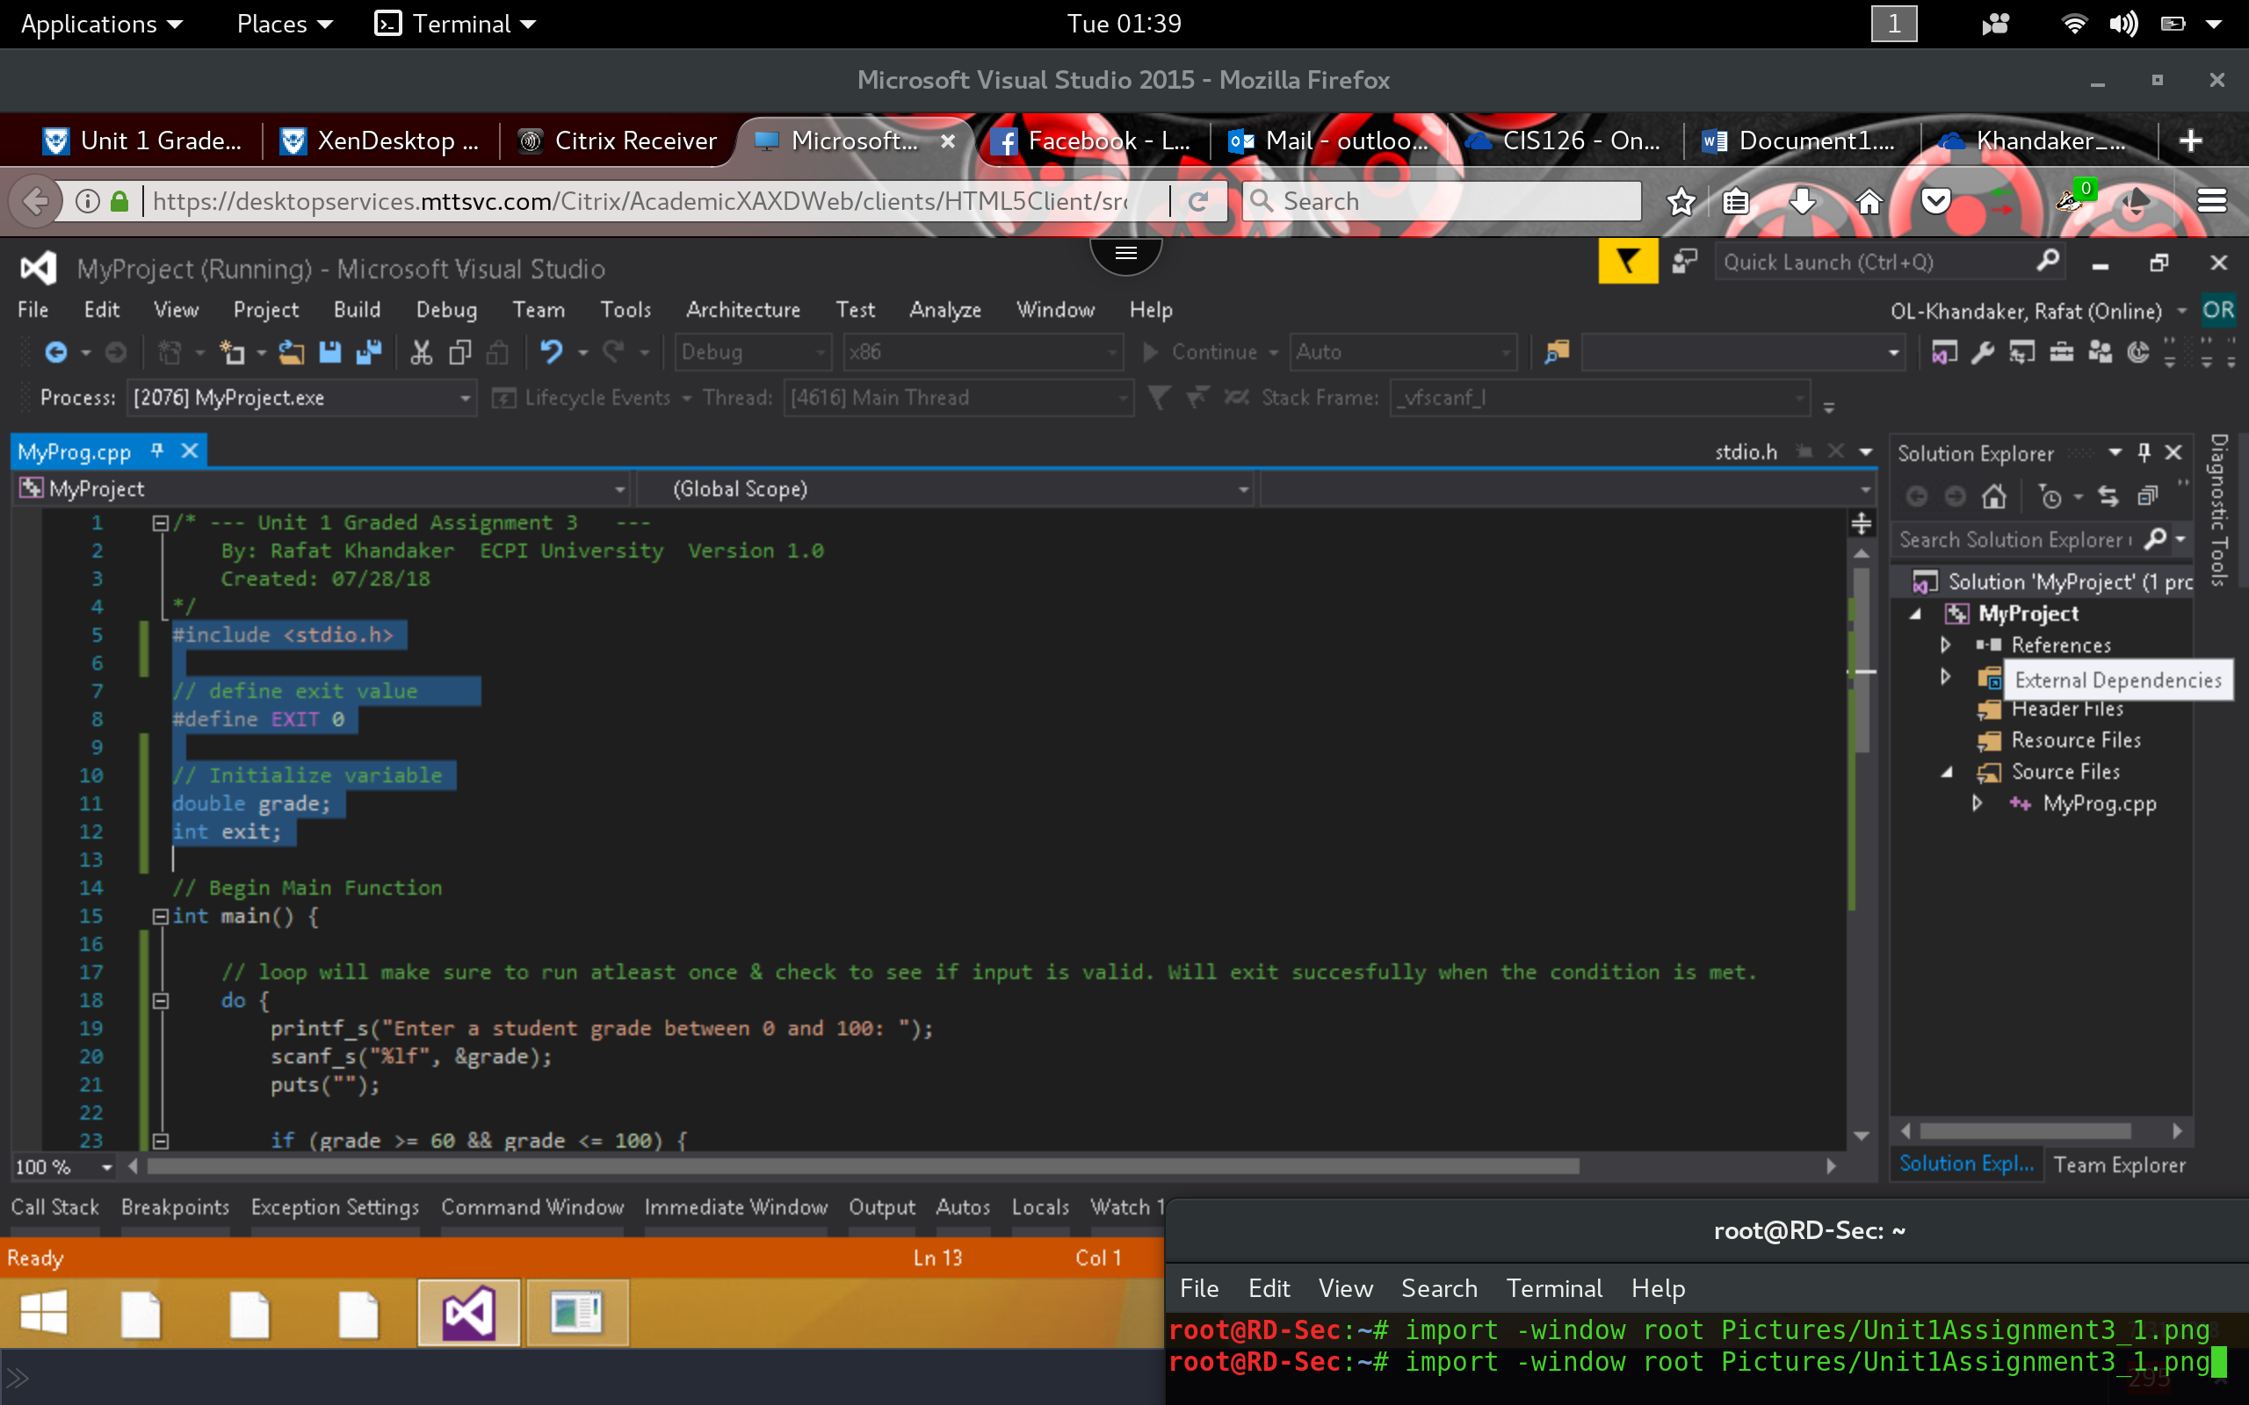

*Do-While statement will ensure that the grade value is within range of valid inputs*

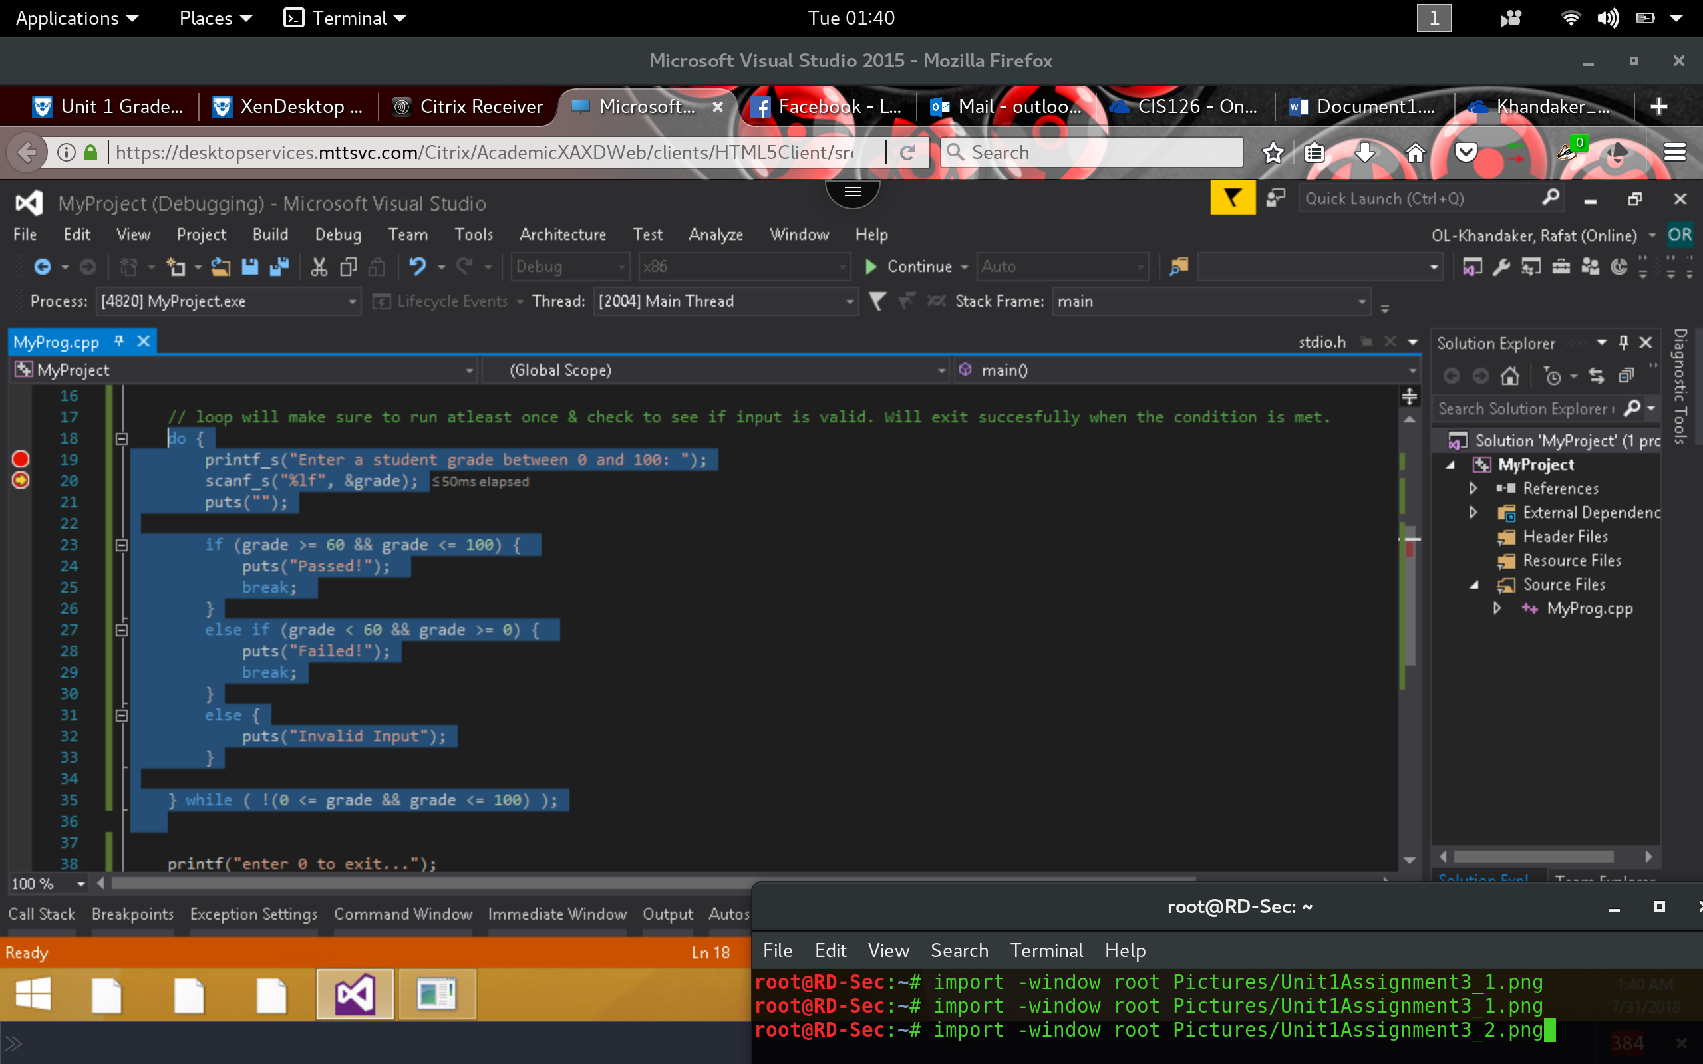

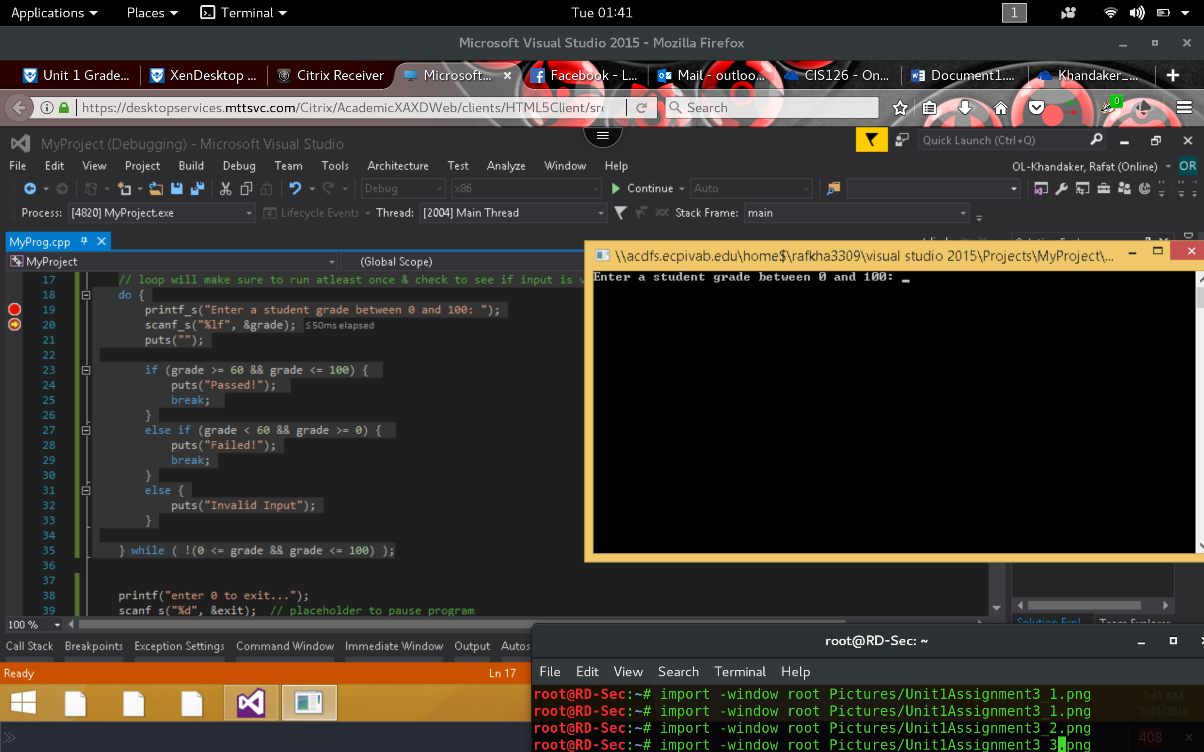

*Entering –1 will go through the "Invalid " prompt & re run task*

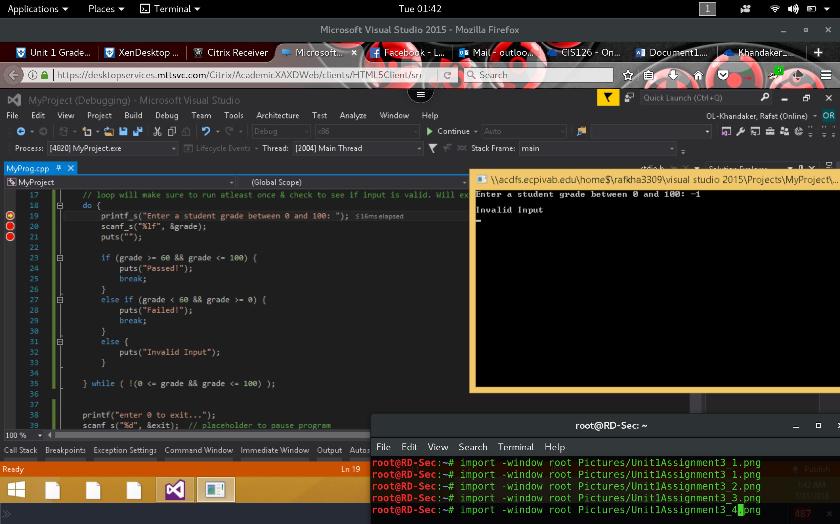

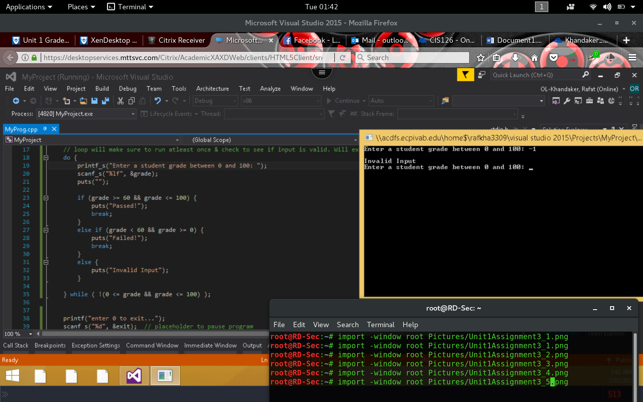

*Entering 101 will re run task with "Invalid input." Entering 50 will exit with "Fail"*

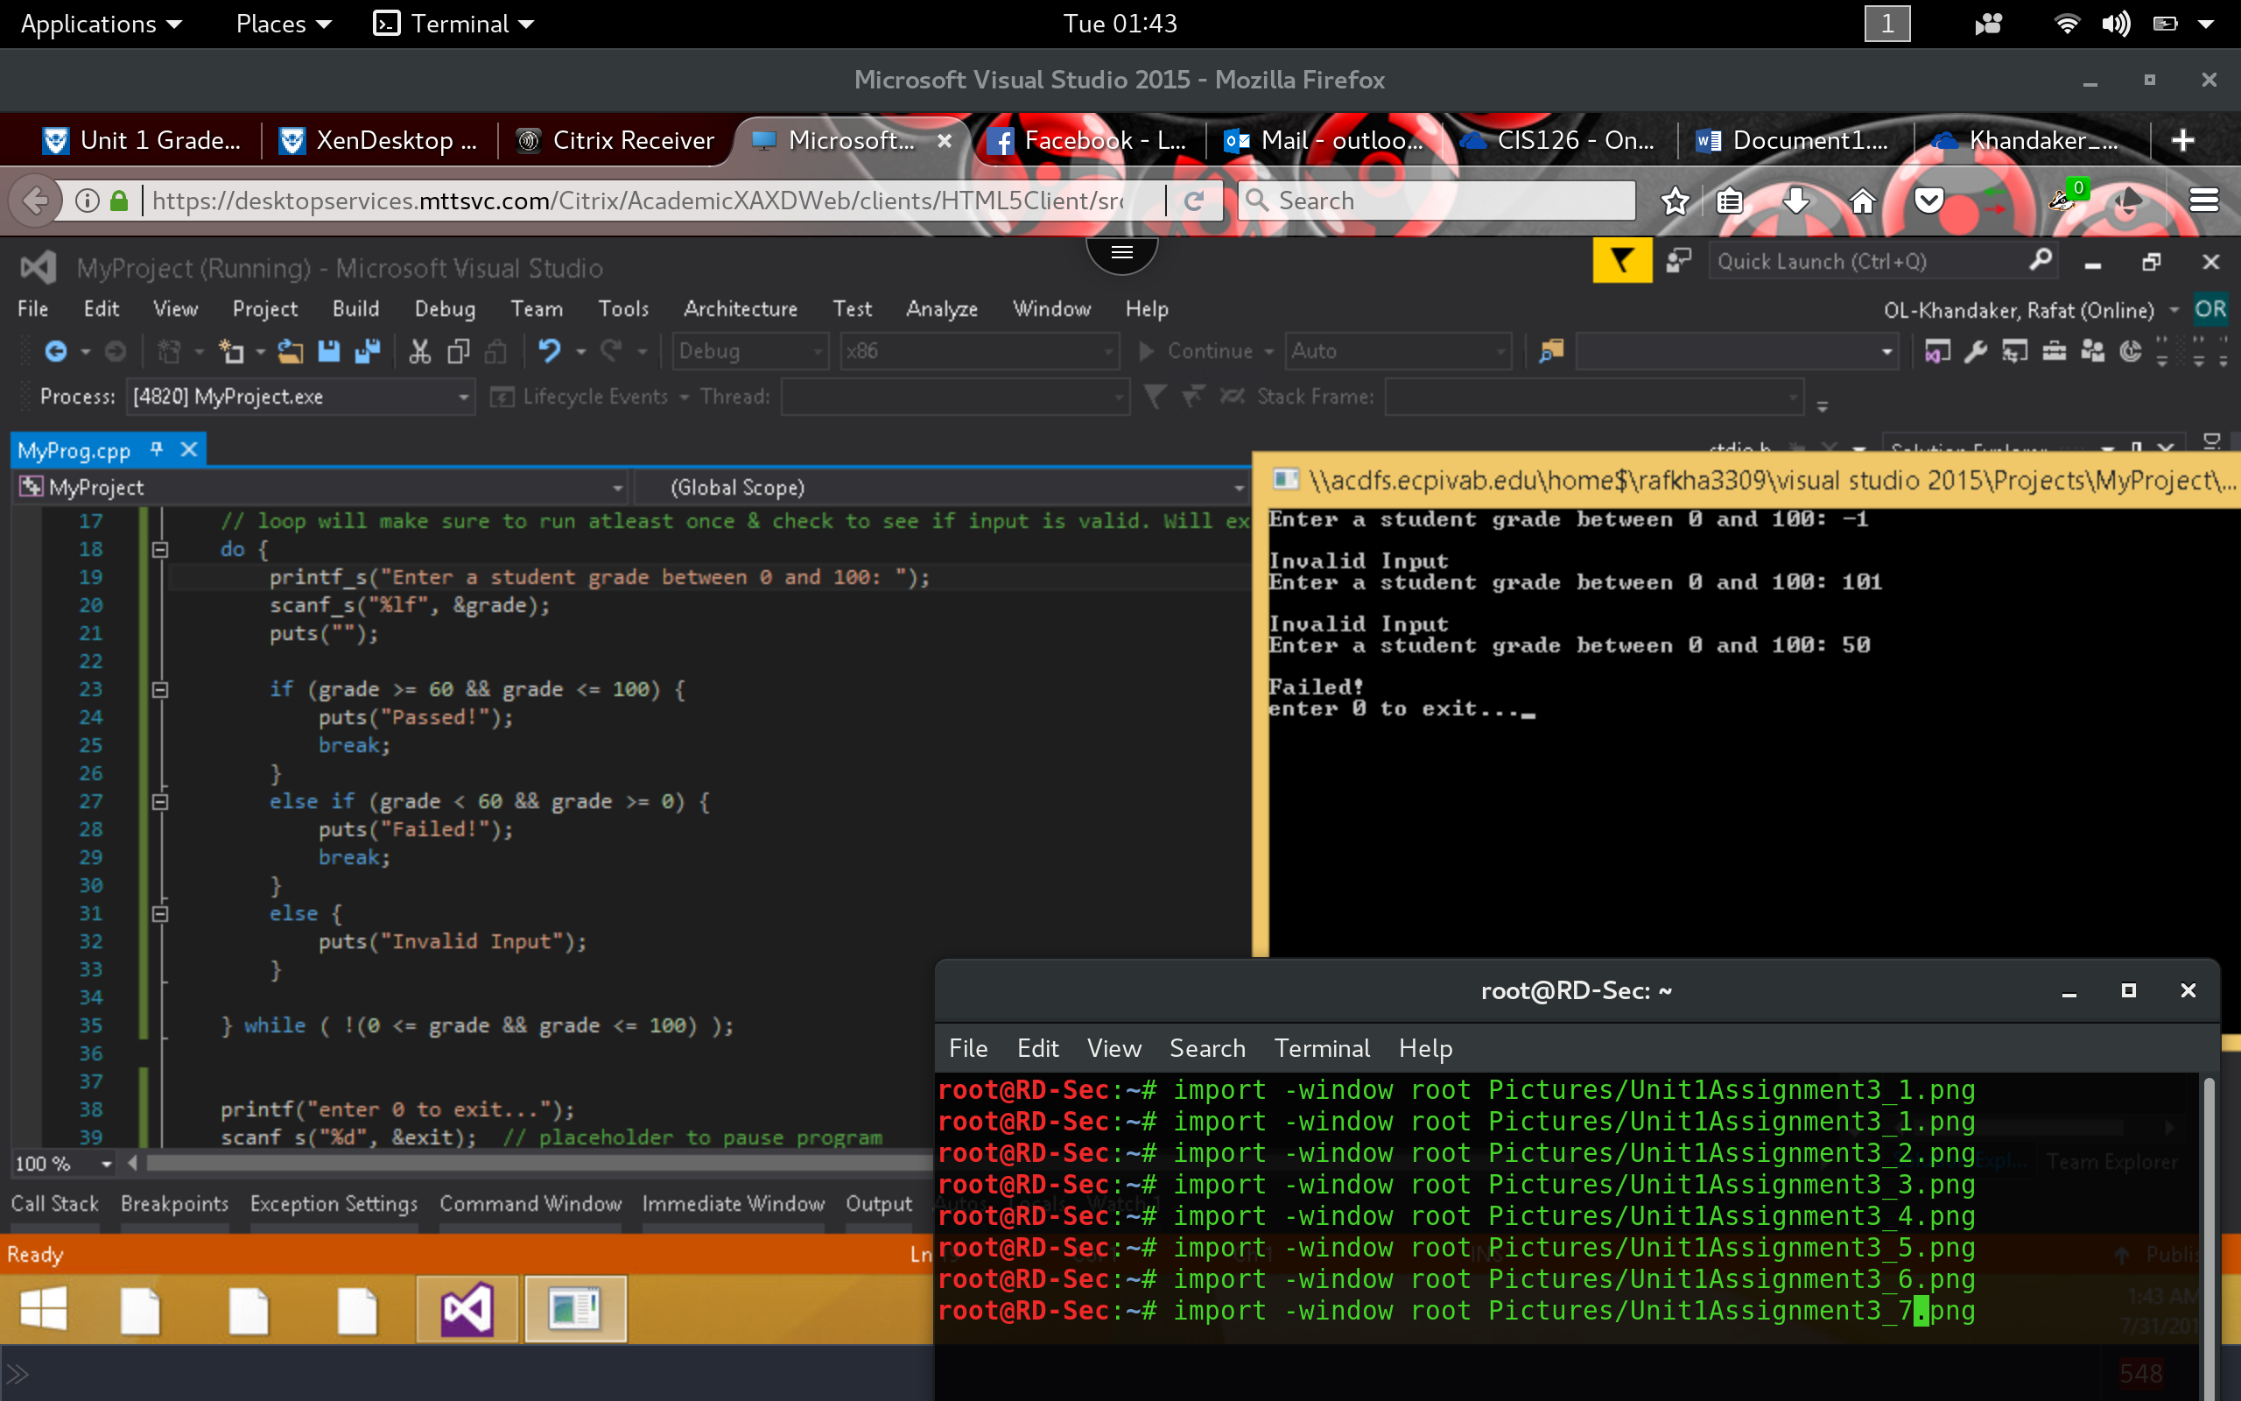

*Finally, entering a passing grade of 65 will "Pass" user & exit program*

